**Signup.jsp**

package com.user;

import java.io.IOException;

import java.io.PrintWriter;

import java.sql.Connection;

import java.sql.DriverManager;

import java.sql.PreparedStatement;

import javax.servlet.ServletException;

import javax.servlet.http.HttpServlet;

import javax.servlet.http.HttpServletRequest;

import javax.servlet.http.HttpServletResponse;

/**

*

* @author KAUSHAL KARKAR

*/

public class Register extends HttpServlet {

/**

* Processes requests for both HTTP <code>GET</code> and <code>POST</code>

* methods.

*

* @param request servlet request

* @param response servlet response

* @throws ServletException if a servlet-specific error occurs

* @throws IOException if an I/O error occurs

*/

protected void processRequest(HttpServletRequest request, HttpServletResponse response)

throws ServletException, IOException {

response.setContentType("text/html;charset=UTF-8");

try (PrintWriter out = response.getWriter()) {

/* TODO output your page here. You may use following sample code. */

out.println("<!DOCTYPE html>");

out.println("<html>");

out.println("<head>");

out.println("<title>Servlet Register</title>");

out.println("</head>");

out.println("<body>");

String firstname=request.getParameter("user_firstname");

String lastname=request.getParameter("user_lastname");

String enrollment=request.getParameter("user_enrollment");

String contactnumber=request.getParameter("user_contactnumber");

String semester=request.getParameter("user_semester");

out.println(firstname);

out.println(lastname);

out.println(enrollment);

out.println(contactnumber);

out.println(semester);

try

{

Class.forName("com.mysql.jdbc.Driver");

Connection con=DriverManager.getConnection("jdbc:mysql://localhost:3306/kaushal","root","root");

String q="insert into kk(firstname,lastname,enrollment,contactnumber,semester) values(?,?,?)";

PreparedStatement pstmt=con.prepareStatement(q);

pstmt.setString(1, firstname);

pstmt.setString(2, lastname);

pstmt.setString(3, enrollment);

pstmt.setString(4, contactnumber);

pstmt.setString(5, semester);

pstmt.executeUpdate();

out.println("done");

}catch(Exception e)

{

e.printStackTrace();

out.println("error");

}

out.println("</body>");

out.println("</html>");

}

}

**Register.java**

Servletpage

<%--

Document : signup

Created on : 25-Jan-2022, 6:17:57 pm

Author : KAUSHAL KARKAR

--%>

<%@page contentType="text/html" pageEncoding="UTF-8"%>

<!DOCTYPE html>

<html>

<head>

<meta http-equiv="Content-Type" content="text/html; charset=UTF-8">

<!-- Compiled and minified CSS -->

<link rel="stylesheet" href="https://cdnjs.cloudflare.com/ajax/libs/materialize/1.0.0/css/materialize.min.css">

<!-- Compiled and minified JavaScript -->

<script src="https://cdnjs.cloudflare.com/ajax/libs/materialize/1.0.0/js/materialize.min.js"></script>

<title>JSP Page</title>

</head>

<body style="background: silver">

<div class=""container>

<div class="row">

<div class="col m6 offset-m3">

<div class="card">

<div class="card-content">

<h3>Register here</h3>

<form action="Register" method="post">

<div class="form center-align">

<input type="text" name="user_firstname" placeholder="Enter your firstname"/>

<input type="text" name="user_lastname" placeholder="Enter your lastname"/>

<input type="text" name="user_enrollment" placeholder="Enter your enrollment"/>

<input type="text" name="user_contactnumber" placeholder="Enter your contactnumber"/>

<input type="text" name="user_semester" placeholder="Enter your semester"/>

<button type="submit" class="btn">submit here</button>

</div>

<div class="loader" style="display: none">

<div class="progress">

<div class="indeterminate"></div>

</div>

<h6>please wait......</h6>

</div>

</div>

</div>

</div>

<script

src="https://code.jquery.com/jquery-3.6.0.min.js"

integrity="sha256-/xUj+3OJU5yExlq6GSYGSHk7tPXikynS7ogEvDej/m4="

crossorigin="anonymous">

</script>

})

<script>

$(document).ready(function(){

console.log("page is ready")

</script>

</body>

</html>

**Web.xml**

<?xml version="1.0" encoding="UTF-8"?>

-<web-app xsi:schemaLocation="http://xmlns.jcp.org/xml/ns/javaee http://xmlns.jcp.org/xml/ns/javaee/web-app_3_1.xsd" xmlns:xsi="http://www.w3.org/2001/XMLSchema-instance" xmlns="http://xmlns.jcp.org/xml/ns/javaee" version="3.1">

<servlet>

<servlet-name>Register</servlet-name>

<servlet-class>com.user.Register</servlet-class>

</servlet>

<servlet-mapping>

<servlet-name>Register</servlet-name>

<url-pattern>/Register</url-pattern>

</servlet-mapping>

-<session-config>

<session-timeout>30 </session-timeout>

</session-config>

</web-app>

**PhpMyAdmin data**

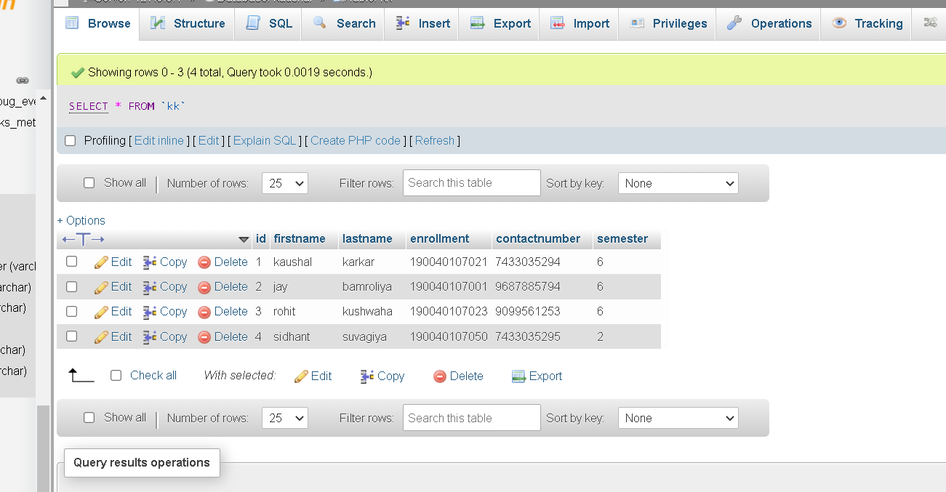

**SQLYOG**